EXPERIMENT 6(a)

6a.Simulation and Performance Evaluation of People–Process–Data–Things IoE Framework using Edge/Fog-to-Cloud Pipeline with MQTT and Node-RED

1. Objective
- To design and simulate the People–Process–Data–Things (PPDT) framework using Internet of Everything (IoE) concepts.
- To establish communication between edge/fog devices and the cloud using MQTT and Node-RED.
- To understand how data is collected, processed, transmitted, and visualized.
- To evaluate system performance based on latency, data delivery, and processing efficiency.
2. Procedure
1. Install the required software: Install Node.js, Node-RED, and the Mosquitto MQTT broker on the computer.
2. Configure MQTT communication: Start the Mosquitto broker and configure MQTT nodes in Node-RED to publish and subscribe to messages using a common topic.
3. Create the Things layer: Simulate sensors or IoE devices that generate sample data, such as temperature, humidity, or device status.
4. Implement the Edge/Fog layer: Process the incoming data locally using Node-RED function nodes. Filter unnecessary data and identify important values before forwarding them.
5. Implement the Cloud layer: Send the processed data through MQTT to a cloud service or a simulated cloud dashboard for monitoring and storage.
6. Represent the PPDT framework:
- People: Users who monitor the system and make decisions.
- Process: Rules used to process data and generate alerts.
- Data: Information collected from sensors and devices.
- Things: Sensors, devices, and connected equipment.
7. Create the Node-RED flow: Connect Inject, Function, MQTT Out, MQTT In, and Debug or Dashboard nodes to demonstrate the complete data flow.
8. Evaluate performance: Measure message transmission latency, successful message delivery, and the effect of edge/fog processing on the amount of data sent to the cloud.
9. Observe the output: Deploy the flow, generate sample messages, and verify that the processed information reaches the MQTT subscriber and dashboard.
.

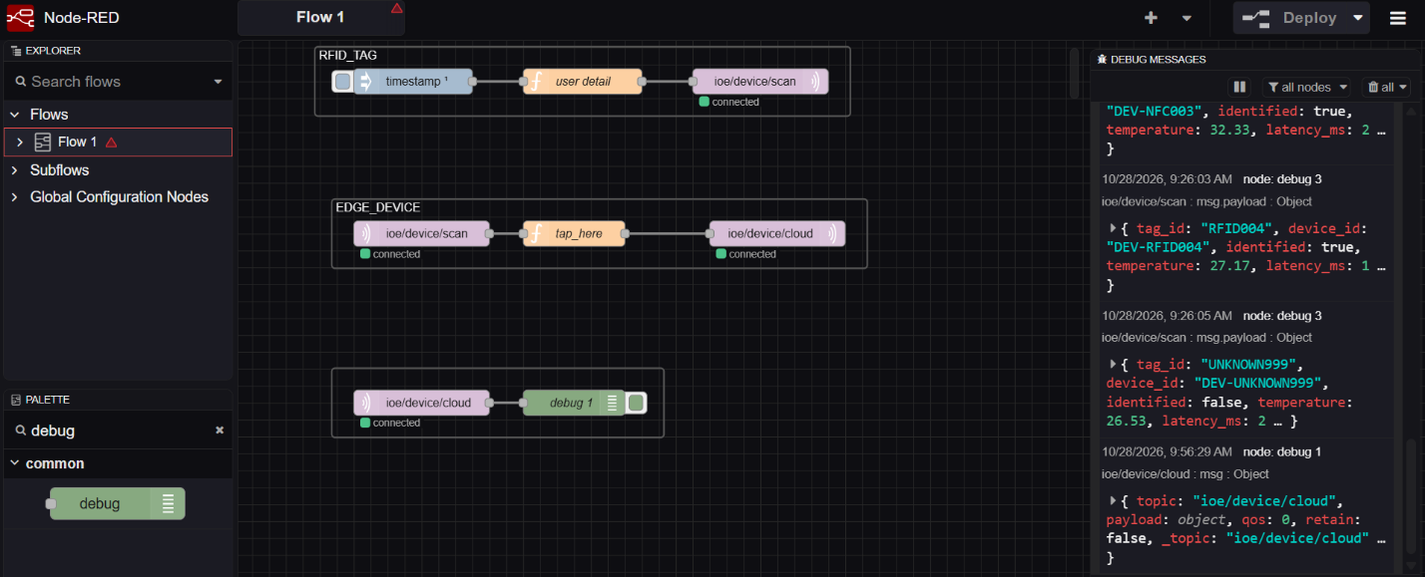
3. Result
The People–Process–Data–Things IoE framework was modelled and simulated using Node-RED and MQTT. Data generated by simulated devices was processed at the edge/fog layer and transmitted to the cloud for monitoring and visualization. The experiment demonstrated communication between the different IoE layers and showed how local processing can reduce unnecessary cloud traffic and support faster responses. System latency and message delivery performance can be evaluated using the simulation results

